SPRINT 1

|  |  |
| --- | --- |
| Date | 17 November 2022 |
| Team ID | PNT2022TMID23566 |
| Project Name | IoT Based Smart Crop Protection System for Agriculture |

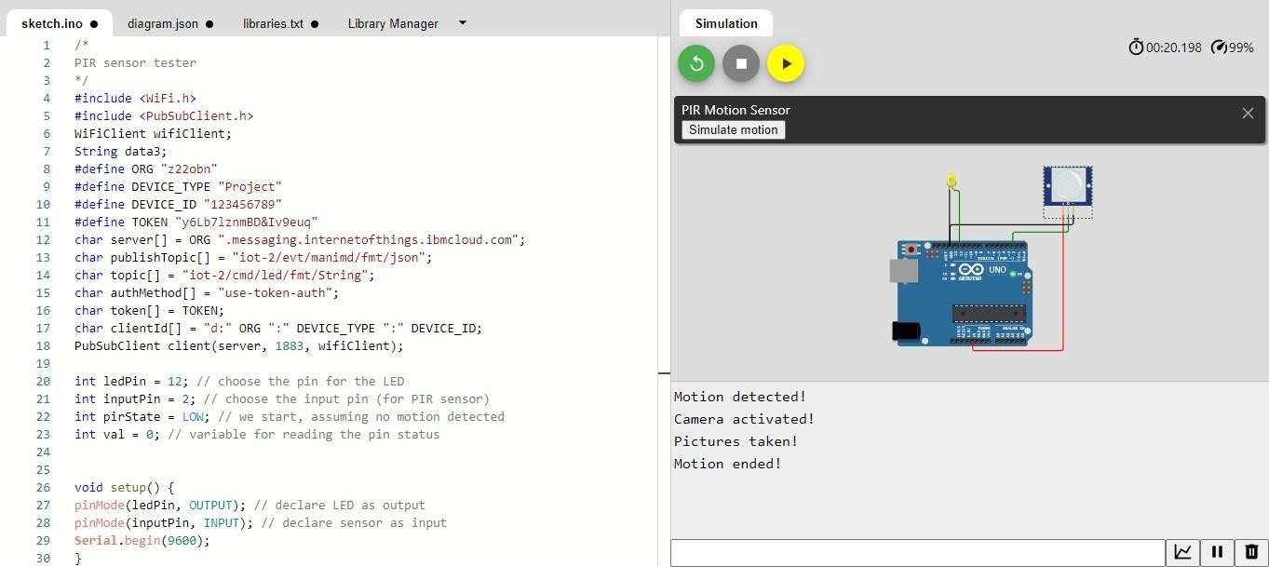

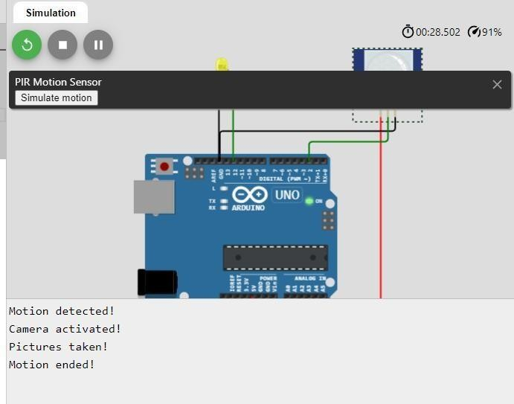

**PYTHON CODE:**

/*PIR sensor tester*/ #include <WiFi.h> #include <PubSubClient.h> WiFiClient wifiClient; String data3;

#define ORG "z22obn"

#define DEVICE_TYPE "Project" #define DEVICE_ID "123456789"

#define TOKEN "y6Lb7lznmBD&Iv9euq"

int ledPin = 12; // choose the pin for the LED

int inputPin = 2; // choose the input pin (for PIR sensor) int pirState = LOW; // we start, assuming no motion detected int val = 0; // variable for reading the pin status

void setup() {

pinMode(ledPin, OUTPUT); // declare LED as output pinMode(inputPin, INPUT); // declare sensor as input **Serial**.begin(9600);

}

void loop() {

val = digitalRead(inputPin); // read input value if (val == HIGH) { // check if the input is HIGH digitalWrite(ledPin, HIGH); // turn LED ON

//void publishData(); if (pirState == LOW) {

// we have just turned on **Serial**.println("Motion detected!"); **Serial**.println("Camera activated!");

delay(1000);

**Serial**.println("Pictures taken!");

// We only want to print on the output change, not state pirState = HIGH;

}

}

else {

digitalWrite(ledPin, LOW); // turn LED OFF

//void publishData(); if (pirState == HIGH) {

// we have just turned of

**Serial**.println("Motion ended!");

// We only want to print on the output change, not state pirState = LOW;

}}}